1. Provide the list of markets in which customer "Atliq Exclusive" operates its business in the APAC region.

SELECT market FROM

gdb023.dim_customer

where customer='Atliq Exclusive' and region='APAC';

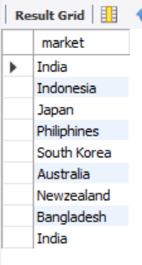

1. What is the percentage of unique product increase in 2021 vs. 2020? The final output contains these fields,

unique_products_2020

unique_products_2021

percentage_chg

WITH unique_products as(

Select

count(distinct case when fiscal_year=2020 then product_code end) as unique_products_2020,

count(distinct case when fiscal_year=2021 then product_code end) as unique_products_2021

from fact_sales_monthly)

select *,

ROUND((unique_products_2021-unique_products_2020)*100 / unique_products_2020,2) as per_diff

from unique_products;

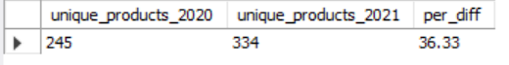

1. Provide a report with all the unique product counts for each segment and sort them in descending order of product counts. The final output contains 2 fields,

segment product_count

SELECT segment, COUNT(Distinct product_code) as product_cnt

FROM gdb023.dim_product

group by segment

order by product_cnt DESC ;

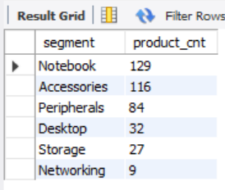

1. Follow-up: Which segment had the most increase in unique products in 2021 vs 2020? The final output contains these fields,

Segment

product_count_2020

product_count_2021

difference

WITH percentage_change as(

Select

d.segment,

count(distinct case when f.fiscal_year=2020 then d.product_code end) as product_count_2020,

count(distinct case when f.fiscal_year=2021 then d.product_code end) as product_count_2021

from fact_sales_monthly f

join dim_product d

on f.product_code=d.product_code

group by d.segment)

select *,

round((product_count_2021-product_count_2020)*100/product_count_2020,2) as prec_diff

from percentage_change

order by prec_diff DESC;

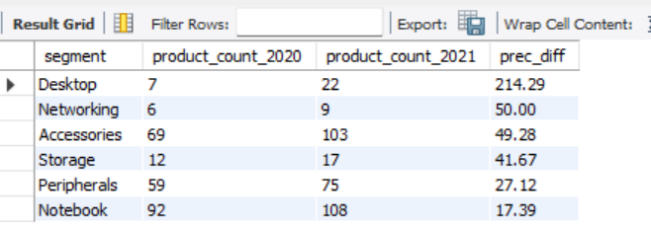

1. Get the products that have the highest and lowest manufacturing costs. The final output should contain these fields,

product_code

product

manufacturing_cost

SELECT

fm.product_code,product, manufacturing_cost

FROM fact_manufacturing_cost as fm

join dim_product as dm

on dm.product_code= fm.product_code

where manufacturing_cost=(select min(manufacturing_cost) from fact_manufacturing_cost)

or manufacturing_cost=(select max(manufacturing_cost) from fact_manufacturing_cost);

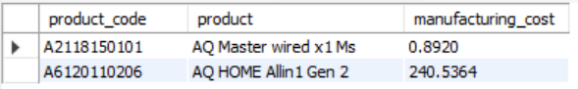

1. Generate a report which contains the top 5 customers who received an average high pre_invoice_discount_pct for the fiscal year 2021 and in the Indian market. The final output contains these fields,

customer_code

customer

average_discount_percentage.

SELECT

f.customer_code,

d.customer,

f.pre_invoice_discount_pct as average_discount_percentage

FROM

fact_pre_invoice_deductions AS f

JOIN

dim_customer AS d ON d.customer_code = f.customer_code

WHERE

f.fiscal_year = 2021

AND market = 'India'

AND f.pre_invoice_discount_pct > (SELECT

AVG(pre_invoice_discount_pct)

FROM fact_pre_invoice_deductions)

ORDER BY f.pre_invoice_discount_pct DESC

LIMIT 5;

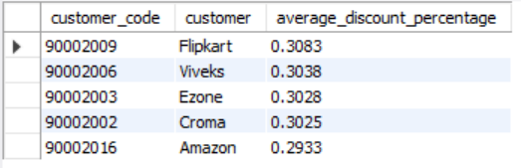

1. Get the complete report of the Gross sales amount for the customer “Atliq Exclusive” for each month.

This analysis helps to get an idea of low and high-performing months and take strategic decisions.

The final report contains these columns:

Month

Year

Gross sales Amount

SELECT

dc.customer,

CONCAT(DATE_FORMAT(fs.date, '%b'),' (',YEAR(fs.date),')') AS 'Month',

fs.fiscal_year,

Round(SUM(fs.sold_quantity * fg.gross_price),2) as gross_sales_amount

FROM

fact_sales_monthly fs JOIN

dim_customer AS dc ON fs.customer_code = dc.customer_code

JOIN

fact_gross_price AS fg ON fg.product_code = fs.product_code

WHERE

dc.customer = 'Atliq Exclusive'

GROUP BY Month;

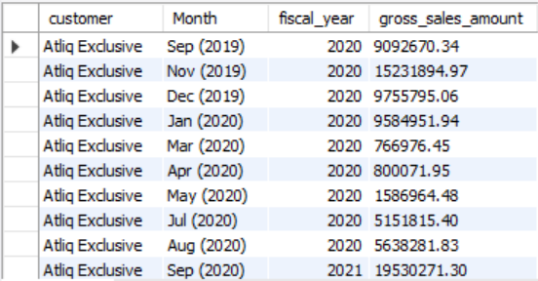

1. In which quarter of 2020, got the maximum total_sold_quantity?

The final output contains these fields

sorted by the total_sold_quantity,

Quarter

total_sold_quantity

With Quarterly_sold_qty as(

SELECT

date,

fiscal_year,

CONCAT('Q',QUARTER(DATE_ADD(date, INTERVAL 4 MONTH))) AS fiscal_quarter,

sold_quantity

FROM

gdb023.fact_sales_monthly)

SELECT

fiscal_quarter AS 'Quarter',

SUM(sold_quantity) AS total_sold_quantity

FROM

Quarterly_sold_qty

WHERE

fiscal_year = 2020

GROUP BY fiscal_quarter

ORDER BY total_sold_quantity DESC;

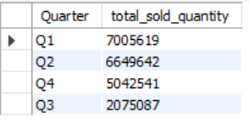

1. Which channel helped to bring more gross sales in the fiscal year 2021 and the percentage of contribution?

The final output contains these fields,

channel

gross_sales_mln

percentage

with gross_sales as(

SELECT

dc.channel ,

fs.fiscal_year,

Round(SUM(fs.sold_quantity * fg.gross_price)/10000000,2) as gross_sales_amount_mln

FROM

fact_sales_monthly fs JOIN

dim_customer AS dc ON fs.customer_code = dc.customer_code

JOIN

fact_gross_price AS fg ON fg.product_code = fs.product_code

where fs.fiscal_year=2021

GROUP BY channel

ORDER BY fs.fiscal_year)

select channel, gross_sales_amount_mln,

(sum(gross_sales_amount_mln)/(select SUM(gross_sales_amount_mln) from gross_sales))*100 as pct_contribution

from gross_sales

group by channel;

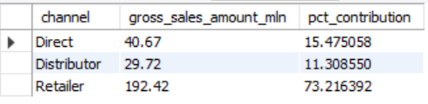

1. Get the Top 3 products in each division that have a high total_sold_quantity in the fiscal_year 2021?

The final output contains these fields,

Division

product_code

product total_sold_quantity

rank_order

with top_products as (

select

d.division,

d.product_code,

d.product,

d.variant,

sum(f.sold_quantity) as sold_qty,

dense_rank() over(partition by division order by sum(f.sold_quantity) desc) as product_ranking

from fact_sales_monthly as f

join dim_product as d

on f.product_code=d.product_code

where f.fiscal_year=2021

group by division,product,variant)

select *

from top_products where product_ranking<=3;

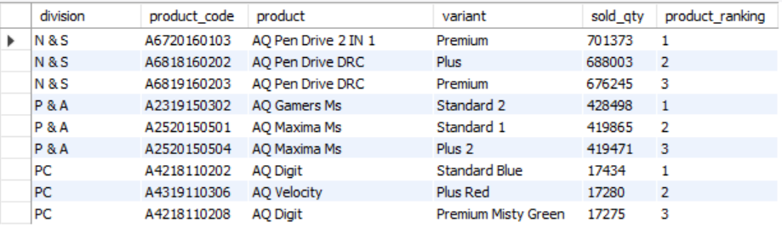

with top_products as (select

d.division,

d.product_code,

d.product,

sum(f.sold_quantity) as sold_qty,

dense_rank() over(partition by division order by sum(f.sold_quantity) desc) as product_ranking

from fact_sales_monthly as f

join dim_product as d

on f.product_code=d.product_code

where f.fiscal_year=2021

group by product)

select *

from top_products where product_ranking<=5;

